**Measurements While Drilling Cost saving using New Technology of Wired Drill-Pipe**

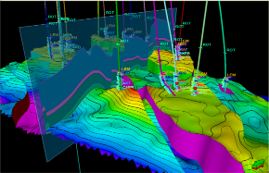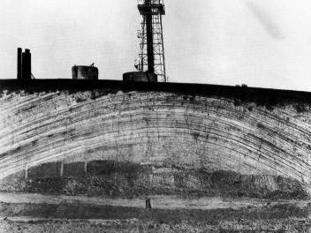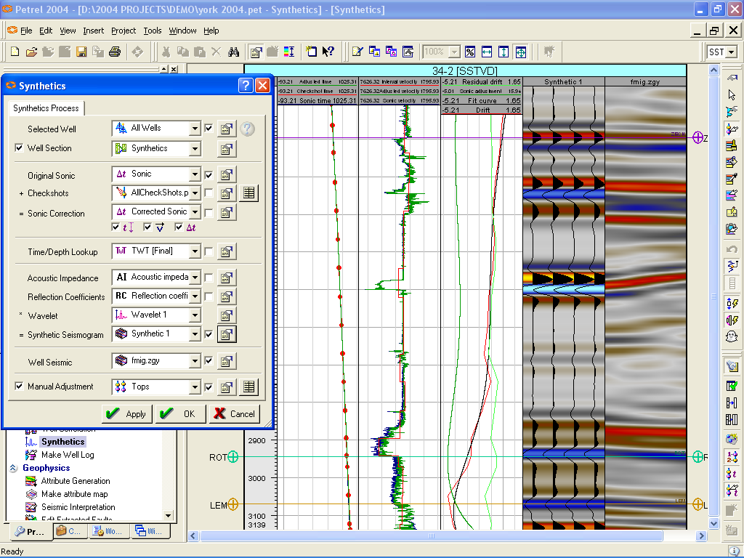

This abstract prepared for the Benghazi International Conference of Oil & Gas

October 9-11. 2018 Benghazi

**By: Ali Saoud, MSC student at Libya Academy**

**And Ibrahim Ben Younes, Oil and Gas Expert - Libya**

**Tripoli – Libya**

**Abstract:**

Presently, the oil and gas industry is increasingly facing challenges to develop the reservoirs found. Most of the easy wells have been drilled and completed. Left are the more challenging fields. The challenges could be anything from deep-water drilling to extended reach drilling. New technologies enables more efficient drilling, better understanding of the downhole environments and provides a method for drilling tough wells with a higher success rate.

One of the most important technologies that help achieving these goals is Measurements While Drilling technology. It proved to be very efficient and promising with new advances every day.

Mud Pulse Telemetryis by far the method most commonly used. Wired Pipe Telemetry is a new technology that allows a vast amount of data to be transferred, which could create new features for the MWD/LWD service, and improve on others.

Wired drill pipe (WDP) technology is one of the most promising data acquisition technologies in today’s oil and gas industry. For the first time it allows sensors to be positioned along the drill string which enables collecting and transmitting valuable data not only from the bottom hole assembly (BHA), but also along the entire length of the wellbore to the drill floor. The technology has received industry acceptance as a viable alternative to the typical logging while drilling (LWD) method. Recently more and more WDP applications can be found in the challenging drilling environments around the world, leading to many innovations to the industry.

The paper Objectives:

* Overview of the MWD technologies and the new technologies available and its advantages of reducing cost and rig time.
* Does Wired Drill Pipe Technology provide enough usable possibilities to make up for its cost?
* The technical aspect of the WDP technology, and the economics of it. It is often challenging to implement new technology before the industry approves of it. So what is wired drill pipe technology? What are the differences between using regular drill pipe and wired drill pipe? Is wire drill pipe the future of data transmission? Is wired drill pipe economically beneficial for the user? Is wired drill pipe just a fancy but not cost-efficient tool for the oil industry, which will not endure into the future?
* Assessing Case studies that show the efficiency of implementing such new technology with real data and results that prove the value of these new technologies and its efficiency.

A **Case stud** discussed the advantages of implementing WPT and Along-string measurements in the Martin Linge (ML) Field in Norway, and the rig time saved by implementing this technology compared to offset wells drilled by MPT technology. Also, drilling problems that were avoided, hence minimizing non-productive time and saving capital costs.

References:

* Hughes, B. (1997) White Paper. INTEQ’s Guide to Measurement While Drilling. USA.
* Hussain Rabia, Well Engineering and Construction, edition 2012.
* Ivamberg Navarro et. al. , A Review of Telemetry Data Transmission in Unconventional Petroleum Environments Focused on Information Density and Reliability, 2015.
* Lamont Doherty Borehole Research. An introduction to logging while drilling. Journal of Petroleum Technology, 2008.
* Olav Gerhard Nygaard, Evaluation of Measurement-While-Drilling, telemetry methods and integration of control systems, Stavenger,2012.
* Schlumberger, White Paper, Orion II,www.slb.com/Orion2.